

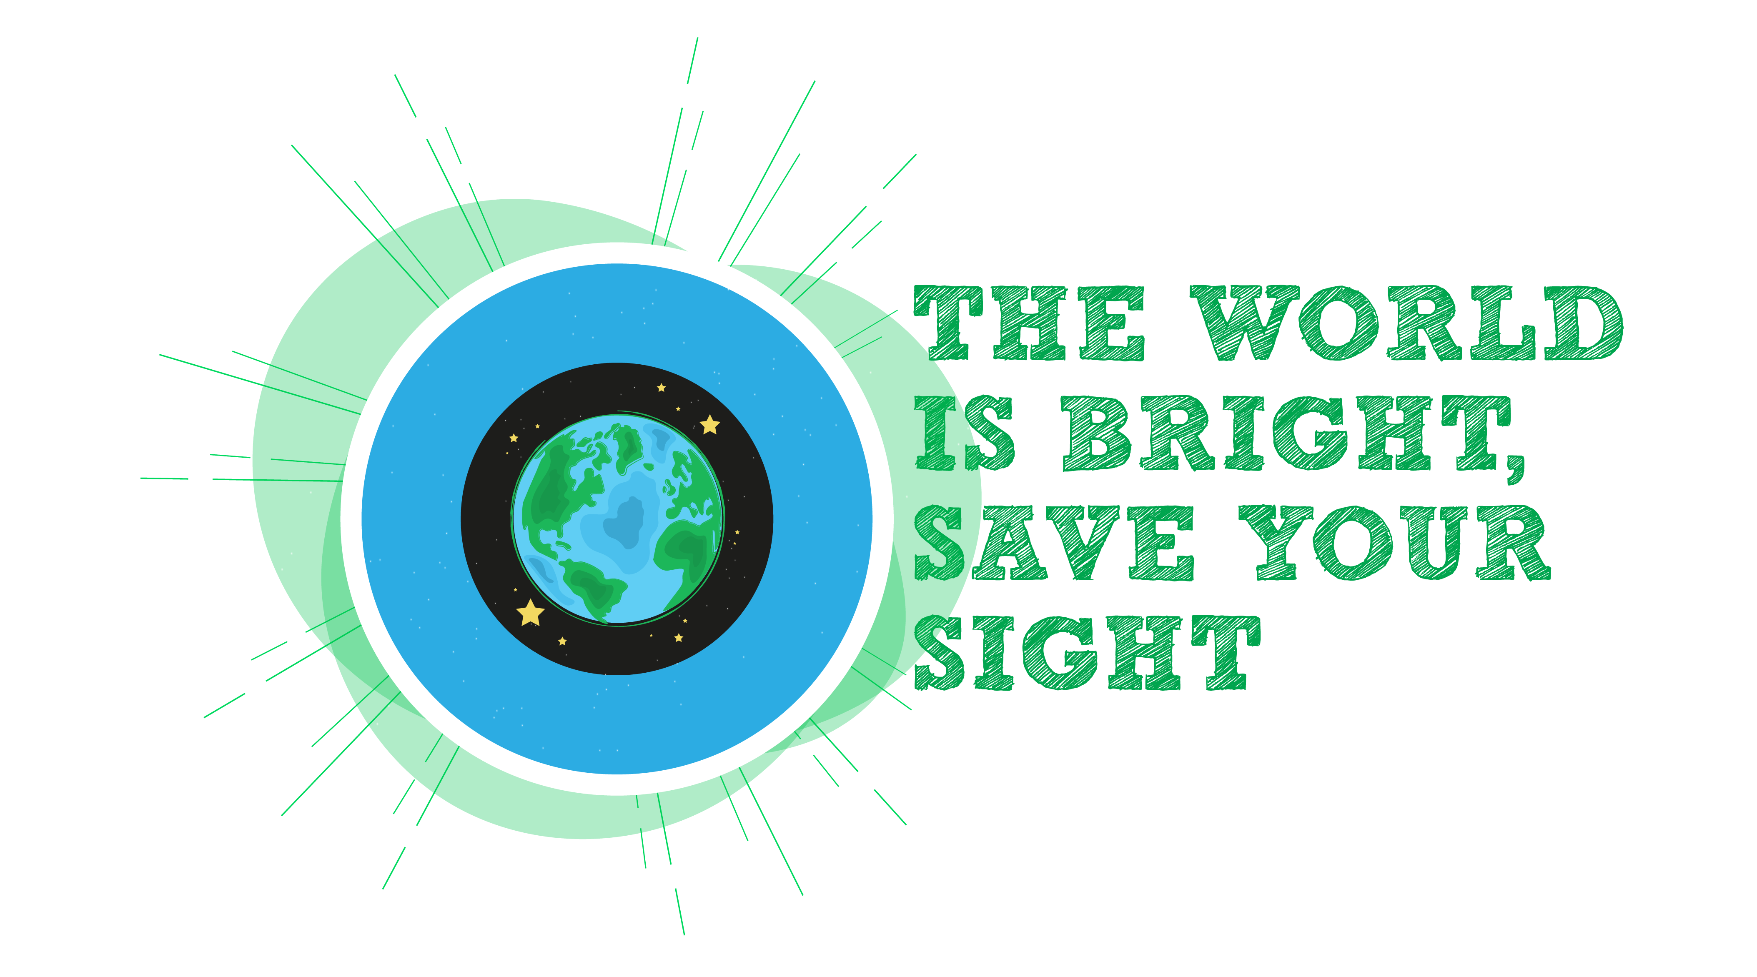

World Glaucoma week is celebrated every year in March. The goal is to raise awareness about Glaucoma and to encourage the general public to have regular eye testing in an effort to detect and treat glaucoma early in order to preserve vision. The theme of this year’s Glaucoma week is “The world is bright, save your sight”. This is to remind us of the beauty there is all around us and just how precious our sight is.

To help in better understanding Glaucoma and why screening for it is such an important public health issue, here are some common questions/ comments by patients regarding glaucoma, and their answers.

What is Glaucoma?

Glaucoma is a group of diseases, which results in progressive damage to the optic nerve. The optic nerve is located at the back of the eye and connects the eye to the brain. It is responsible for transmitting images to the brain to enable us to see. Optic nerve damage causes loss of vision.

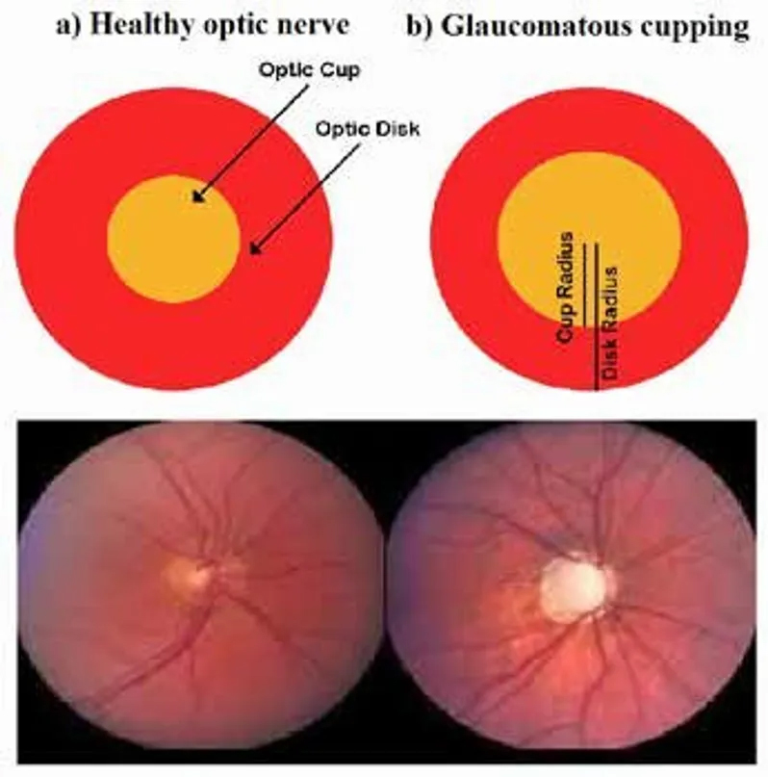
Novaeyecares.com

Glaucoma is the second leading cause of blindness worldwide and the main cause of irreversible blindness.

There are many different types of glaucoma. Primary Glaucoma is most common, however secondary Glaucoma, due to factors such as Diabetes, trauma and use of steroid medications, are also seen in our population.

I know that I don’t have glaucoma because my eyes feel fine and my vision is good.

There are many different forms of Glaucoma, however, the most common type in our population and worldwide is usually asymptomatic. This means that most patients will have no idea that they have early or moderate Glaucoma unless detected by an eye care professional.

Glaucoma causes peripheral visual field loss meaning that the side vision is affected first. This happens gradually over many years and the person subconsciously compensates, therefore, the field loss often goes unnoticed. One may only start to notice changes in his/her sight when the condition becomes severe and tunnel vision develops as the central vision starts to become involved. This is why Glaucoma is sometimes referred to as “The silent thief of sight”. It is remarkable in that, even at the very advanced stages where patients may have tunnel vision and be functionally blind, they may still have 20/20 vision at the centre of the tunnel.

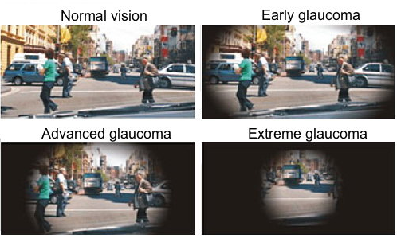meyesight.net

What causes Glaucoma?

Glaucoma is thought to result from a combination of factors but the main mechanism is believed to be due to the pressure within the eye, known as the intraocular pressure (IOP) being too high. 50% of glaucoma patients, however, have normal intraocular pressure. Damage occurs to the optic nerve, which causes vision loss.

The main risk factor for glaucoma is elevated eye pressure but other important risk factors include a family history of glaucoma, black race and increased age. Systemic diseases such as Diabetes and Hypertension are also thought to increase risk.

Is there anything I can do to prevent Glaucoma?

There are no lifestyle or nutritional factors known to help prevent primary glaucoma however, control of chronic diseases can help prevent secondary types of glaucoma.

Our focus is therefore on early detection and treatment.

How often should I be checked for Glaucoma?

Before age 40: every 2-4 years
Age 40-60: every 2-3 years
Over age 60: every 1-2 years

What does Glaucoma screening entail?

Glaucoma screening involves a comprehensive eye exam. Your eye care professional will check your vision and eye pressure and perform a dilated eye exam. Depending on the findings, additional tests may be ordered, the most common of which is a visual field test to check your peripheral or side vision.

Glaucoma screening will also be able to detect other eye diseases that may be present.

How is Glaucoma treated?

As there is no cure for glaucoma, its management often requires lifelong treatment to lower the intraocular pressure and monitoring for progression. Your doctor will often start with eye drops. Other treatment options include laser and surgery depending on the type of Glaucoma. Continued monitoring with special testing is usually necessary.

If you have been diagnosed with Glaucoma, it is important that you adhere to your treatment to prevent progression of the disease and loss of vision.

