
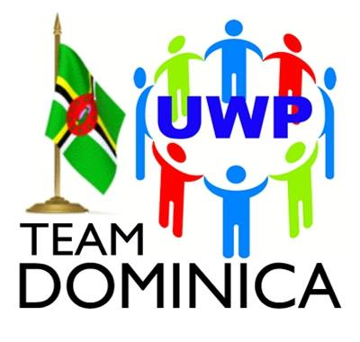
UNITED WORKERS PARTY
6 River Street, Roseau, Commonwealth of Dominica
uwpdaoffice@gmail.comwww.uwpteamdominica.com
President: Lennox Linton; Political Leader: Dr. Thomson Fontaine

Friday 26th April 2024

Honourable Annette Sanford
Kalinago Chief Elect
Kalinago Territory
Commonwealth of Dominica

SUBJECT: CONGRATULATIONS ON ELECTION TO OFFICE OF
KALINAGO CHIEF

Dear Honourable Sanford,
The Executive and Supporters of the United Workers Party-TEAM Dominica (UWP) extends sincerest Congratulations to you on your being elected to the Office of Kalinago Chief at the Elections on Monday 22nd July 2024, called for the purpose of electing a Chief.
Your commitment to the Kalinago People, dedication to advancing their socio-economic wellbeing, charitableness, unimpeachable character and integrity are some of the virtues that have been continually exhibited by you, which were pivotal to your Historic Victory.
Every good wish is extended to you as you commence the discharge of your duties of unifying the Kalinago People in particular, and the citizenry of the Commonwealth of Dominica generally.
May the Lord’s blessings and grace be ever present with you as you serve the residents of the Kalinago territory.
Respectfully
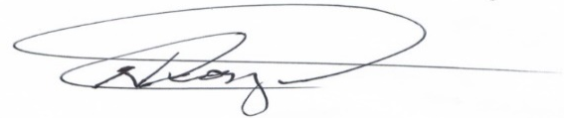
NICHOLAS GEORGE (Mr.)
General Secretary
United workers Party-TEAM Dominica

