Wanted
Information leading to arrest/conviction
Reward $1000

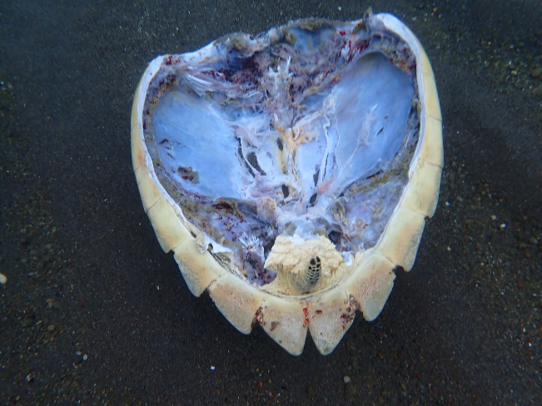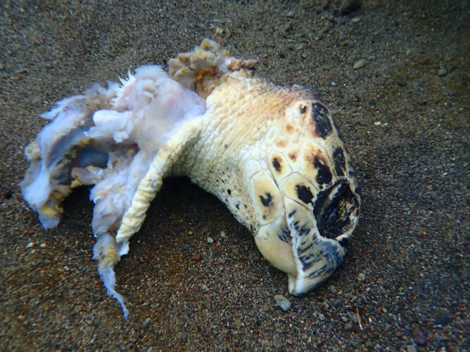
DOMSETCO
(767) 265-0908 (767) 235-4091

